
SRM Institute of Science and Technology
SET C
College of Engineering and Technology
School of Computing
SRM Nagar, Kattankulathur – 603203, Chengalpattu District, Tamilnadu
Academic Year: 2022-23 (EVEN)
Test: CLA-T1 Date: 10.02.2023
Course Code & Title: 18CSC205J - Operating Systems Duration: 50 Minutes
Year & Sem: II Year / IV Sem Max. Marks: 25

Course Articulation Matrix: (to be placed)
S.No | Course Outcome | PO1 | PO2 | PO3 | PO4 | PO5 | PO6 | PO7 | PO8 | PO9 | PO10 | PO11 | PO12 | PSO1 | PSO2 | PSO3
1 | CO1 | 3 |  | 3 |  |  |  |  |  |  |  |  |  | 2
2 | CO2 | 2 | 1 | 3 |  |  |  |  |  |  |  |  |  |  | 2
3 | CO3 | 3 | 2 | 2 |  |  |  |  |  |  |  |  |  | 2
4 | CO4 | 3 | 2 | 2 |  |  |  |  |  |  |  |  |  |  | 2
5 | CO5 | 3 |  | 2 | 2 |  |  |  |  |  |  |  |  | 2

Part - A
(10 x 1 = 10 Marks)
Instructions: Answer all
Q. No | Question | Mark | BL | CO | PO | PI Code
 | In UNIX, the return value for the fork system call is _____ for the child process and _____ for the parent process.  A. A Negative integer, Zero  B. Zero, A Negative integer  C. Zero, A nonzero integer  D. A nonzero integer, Zero  Answer: C. Zero, A nonzero integer | 1 | 2 | 1 | 1 | 1.6.1
 | The time taken to switch between user and kernel modes of execution be t1 while the time taken to switch between two processes be t2.  i) Which of the following is TRUE?  A. t1 > t2  B. t1 = t2  C. t1 < t2  D. nothing can be said about the relation between t1 and t2  Ans: C. t1 < t2 | 1 | 3 | 1 | 3 | 3.7.1
 | The state in which the thread waits until the processor is made available  a. standby  b. ready  c. running  d. waiting  Ans: b | 1 | 1 | 1 | 1 | 1.6.1
 | …………… is a large kernel containing virtually the complete operating system, including, scheduling, file system, device drivers and memory management.  A) Multilithic kernel  B) Monolithic kernel  C) Micro kernel  D) Macro kernel  Answer : B | 1 | 1 | 1 | 1 | 1.7.1
 | …………… refers to the ability of multiple process (or threads) to share code, resources or data in such a way that only one process has access to shared object at a time.  A) Synchronization  B) Mutual Exclusion  C) Dead lock  D) Starvation  Answer : B | 1 | 2 | 1 | 1 | 1.6.1
PART B – 10 Marks
Answer any Two Questions
 | Summarize about four resources that will be allocated by operating system to users and processes. Explain how they are managed by OS.  Key:  For each resource 2.5 marks. (Any four resource can be explained)  Memory Management:  - This refers to management of the main or primary memory.  - Main memory is a quick storage area that may be accessed directly by the CPU.  - To execute a program, it has to be present in the main memory. After execution the memory region is released to use by other programs. Therefore, there can be more than one program present at a time. Hence, it is required to manage the memory.  - Functions of OS in Memory management:  - Allocates and deallocates the memory.  - Keeps a record of which part of primary memory is used by whom and how much.  - Distributes the memory while multiprocessing.  - In multiprogramming, the operating system selects which processes acquire memory when and how much memory they get.  Process Management  - Every software that runs on a computer, whether in the background or in the frontend, is a process. A Program in execution is called as process.  - Multiple process will be waiting in a queue to get the processor for processing.  - OS is the decision maker which decides the order of process for processing. The process management unit executes different CPU scheduling algorithms to determine the order of the process for execution.  - It also determines the amount of processing time allocated to each When more than one process runs on the system  - Allocates and deallocates processor to the processes.  - It also tracks the status of these processes to understand if they succeed or fail.  - Since every device should get a chance to use the processor. Hence, the OS makes sure that the devices get fair processor time.  - It the efficiency of the system.  File Management  - Data is stored on files. OS helps to create, edit, update and delete files.  - It helps in transferring files from one device to another.  - It specifies which process receives the file and for how long.  - It also keeps track of information, location, uses, status, and so on.  - The operating system is also responsible for organizing the files on the disk.  - Allocates and deallocates resources.  - Decides who gets the resources.  I/O Management  Any kind of Input, we want to give to the computer goes through the operating system. Any output that we get is also acted upon by the Operating System. This management involves coordinating various input and output devices  Ex:  When the user instructs the system to play abc.mp3 on his computer using a music application. Here, the OS will first read the audio file from his hard disk (which is the storage device from where the Input is retrieved) and then send the player output to the speakers (output device) where it will be played | 10 | 2 | 1 | 1 | 1.7.1
 | What is critical section problem. How it is handled by the operating system.  The critical section refers to the segment of code where processes access shared resources, such as common variables and files, and perform write operations on them.  Since processes execute concurrently, any process can be interrupted mid-execution. In the case of shared resources, partial execution of processes can lead to data inconsistencies. When two processes access and manipulate the shared resource concurrently, and the resulting execution outcome depends on the order in which processes access the resource; this is called a race condition  Race conditions lead to inconsistent states of data. Therefore, we need a synchronization protocol that allows processes to cooperate while manipulating shared resources, which essentially is the critical section problem  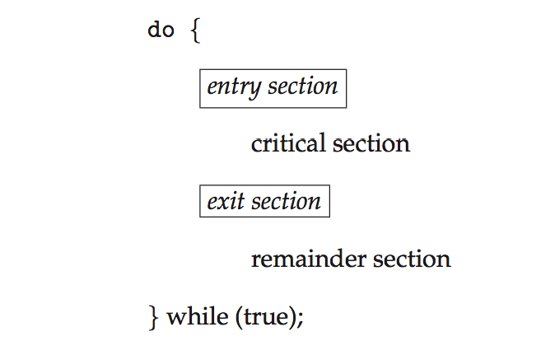  Solutions to the critical section problem  Any solution to the critical section problem must satisfy the following requirements:  - Mutual exclusion: When one process is executing in its critical section, no other process is allowed to execute in its critical section.  - Progress: When no process is executing in its critical section, and there exists a process that wishes to enter its critical section, it should not have to wait indefinitely to enter it.  - Bounded waiting: There must be a bound on the number of times a process is allowed to execute in its critical section, after another process has requested to enter its critical section and before that request is accepted. | 10 | 2 | 1 | 1 | 1.6.1
 | Multiple jobs can run in parallel and finish faster than if they had run sequentially. Suppose that two jobs, each needing 20 minutes of CPU time, start simultaneously. How long will the last one take to complete if they run sequentially? How long if they run in parallel? Assume 50% I/O wait time.  Ans:  Case1: Sequential  I/O wait: 50%  CPU Time: 20 minutes  Total Job time : 20/0.5 = 40 minutes  Total time : 40/.5 = 80 minutes  Case 2: Parallel:  Time = 1-0.5^2 = 0.375 CPU utilization / min  20 min CPU time 20/0.375 = 53.3.mins | 10 | 4 | 1 | 3 | 3.7.1

